

Wezzle
Game Design Overview
CONFIDENTIAL

January 10, 2008
Overview
Wezzle is a single-player subtractive block-based match-three puzzle game. It is a game targeted at casual male and female gamers aged 24-35. Wezzle’s projected release date is first quarter of 2009.

Game Mechanics
Wezzle is a subtractive block-based match-four puzzle game.
In popular games such as Tetris, Alchemy and countless others, players must add blocks to the game board in order to make lines. Wezzle reverses this concept by having players remove blocks to make lines.

Game Play
In Wezzle, the player uses Pieces to remove Tiles from a game board in order to make Lines. A game board consists of up to 80 tiles stacked in a 10x8 matrix formation. When tiles are removed, the pieces fall in a predictable way. If three or more tiles of the same colour are touching, either vertically or horizontally, a line is removed and scored.

Tiles
Blocks in Wezzle are called tiles. There are three separate tile types in Wezzle: Normal tiles, Multiplier tiles and Item tiles Each tile can be one of five colours: red, yellow, teal, purple or green. All tiles when removed by a piece are worth 10 points each. For the special properties of item and multiplier tiles to work, they must be consumed as part of a line. Additionally, all tiles, when part of a line, are worth 50 points each. There can only ever be a maximum of three multiplier tiles and three item tiles on the board at once.
Multiplier and Item tiles react differently when consumed in a line. There are three types of multipliers: 2x, 3x and 4x. A multiplier tile, will increase the score of a line by 2, 3, or 4 times depending on its type.
There are four types of item tiles: Bomb, Rocket, Gravity and Star. To trigger the effect of an item tile, the tile must be consumed as part of a line. A bomb tile, when consumed as part of a line, will explode and remove all adjacent tiles. A rocket tile will remove all tiles in the pointed direction of the rocket. The gravity tile will change the game’s gravity in the pointed direction. Finally, the star tile will remove all tiles that share the colour of the star tile. Bomb and rocket tiles have the additional property that if their effect hits another item, it will consume that item as if it was in a line. Chains of rockets coupled with bombs are frequent at later levels.
There is one final special tyle type: the Wezzle tile. Situated at the bottom left of the game screen is a wezzle counter. When this counter reaches zero, the wezzle piece spawns at a random location on the board. The wezzle piece eats up score until it is removed from the game board in a line. While the wezzle piece is on the board, game progress is halted. The wezzle counter decreases every time a move is made where no lines are consumed. The starting value of the wezzle timer is dependant upon the level the player is on.

Pieces
Players remove tiles from the game board using pieces. Pieces come in a variety of shapes and sizes. They can be as short as one block or as large as three blocks. The player may rotate and move the piece to any place on the game board as long as at least one square of the piece is over a tile. When the player uses a piece on the game board, the tiles that the piece covers are removed, and the remaining tiles on the board fall in a predictable way. This is called refactoring.

Refactoring
When the Wezzle game board refactors, all tiles fall down to fill any empty space, and then all tiles slide to the left to fill any empty space.

Dropping
After a refactoring takes place, new tiles are dropped into random columns on the game board to take the place of those removed by the piece (otherwise, the game board would quickly run out of tiles). The amount of tiles dropped is equal to the number of tiles removed, plus an additional amount related to the current level that the player is on. Only one special tile can be dropped into the board at any time. There is also a chance for no special tiles.

Timer

Located at the top of the game screen is a timer. The timer is set initially for 15 seconds and decreases as the game level increases. The timer is constantly counting down to zero. If the timer reaches zero, the piece is automatically consumed. The minimum time on the timer is five seconds. Once the player has reached the five second mark, game difficulty is no longer influenced by timer length.

Lines
A line occurs when three or more blocks of the same colour are touching in either a vertical or horizontal pattern. When a line match occurs, the blocks that make up the line are removed from the board, causing it to refactor. Lines are centrally important to Wezzle game play. Multipliers and items can only be consumed in lines. As well, line cascades are a large contributor to score.

Cascades
A cascade occurs when, after the board has refactored because of a line match, a new line is immediately matched before the player has had a chance to use a new piece. Each step in a cascade awards an increasing bonus.

Levelling Up
Wezzle is a continuous game without pauses for levelling up. When the player passes a level, she is rewarded by having the bottom line of the game board removed. Players should keep this in mind because this often removes unused items and multipliers.

Difficulty
Game difficulty in Wezzle is controlled through four variables: time-per-turn, tile penalty, target score and wezzle piece.
The time-per-turn is the amount of time a player is allotted before she is forced to use her piece. When the timer reaches zero, the piece is applied wherever it happens to be on the board. The time-per-turn is decreased by an amount each level until it reaches a minimum value. At that point, it is no longer decremented.
The tile penalty is the amount of extra tiles that are added to the game board after each turn, in addition to the number of tiles in the piece. The tile penalty starts at one and increases by one every three levels. The tile penalty has a maximum value, at which point no further tiles are added to the penalty.
The target score is the amount of points a player must accumulate before she is done the level. In Wezzle, this amount is increased by a constant amount each level.
The wezzle piece consumes all score while present on the game board. When the wezzle piece is present, it is in the player’s best interest to remove it from the board.
Player’s can choose to start on whatever difficulty level they desire from the main menu.

Tutorials

The Wezzle tutorial system is built to familiarize players with the game environment and especially item usage. The first time the game is played, the player will be forced through a series of tutorials. The tutorials occur at the start of the game and any time a new piece is introduced. The tutorial allows the player to make use of the item as many times as she likes until she is comfortable. Tutorials can be replayed from the main menu.

Achievements

There is a rank-based achievement system in Wezzle. Bronze level achievements are the easiest and should be achievable by all players. Silver level achievements are slightly more difficult and again will be easily achieveable by most players. Gold achievements will be difficult and only achievable to good players. Platinum achievements will be extremely difficult and only achieveable to the few extremely good players.
Completing achievements will unlock hidden rewards within the game including different music, background themes and even unlockable mini games/special game modes. Players are able to monitor their achievements and unlocked items from the main menu.

High Scores

The top ten high scores from game play are saved and viewable for players through the main menu. Additionally, players can submit their high scores and achievements to our online database to be displayed on our website. The current high score is shown at all times on the game screen. As well, the player can view the high score list by clicking on the high score button during game play or via the main menu.

Game Flow

General Flow
Splash Screens
Main Menu
Game
Tutorial

High Scores
Achievements
Special Games
In-Game Menu

Game Board Flow

Place Piece
Refactor I
Refactor II
Drop Tiles
Move/Rotate
Use
No Lines
Lines
Lines
No Lines

Level Design Objectives
Levels in Wezzle are continuous. However, the initial levels generated by Wezzle must still abide by certain constraints. The principal constraint is that a new game board must not have more than three tiles of the same colour side-by-side. This is done in order to prevent the player from receiving a line match at the beginning of a round. The level generator must also be able to create boards of differing sizes, as this is used in part to control the game difficulty level and to generate the initial boards for higher difficulty levels.

Game Controls

Piece Placement
As the player places her piece, she can control it in three ways using either the mouse or keyboard. She can move the piece using the mouse or directional arrows, use the piece by left clicking or pressing the space bar, rotate the piece by right clicking or pressing the ctrl button.

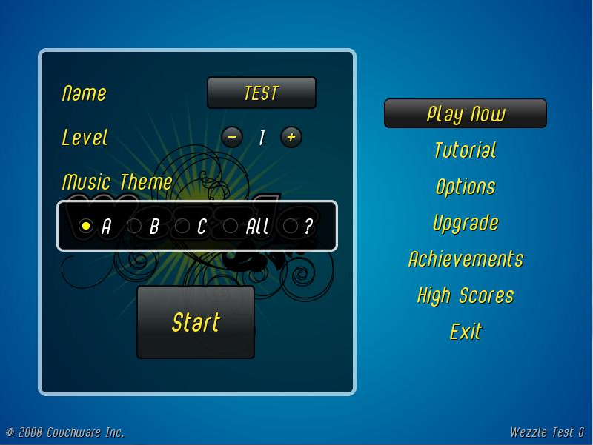
Figure 1. Wezzle Main menu

Menus

There are two menu’s within the Wezzle game. The main menu is only available outside of the game and controls the game setup including level, music and player name. The main menu has options to view achievements, high scores, replay the tutorial and exit the game. The option to upgrade to a full version of the game is also available.
The in-game menu allow the player to pause, modify certain game options such as sound and music and retrieve the game help. The options scren also allows the player to return to the main menu. While the game is paused, the stats of the current game are shown, including lines, moves and line/move ratio.
Menus in Wezzle are controlled by either the mouse or the directional pad and enter key.

Game Interface
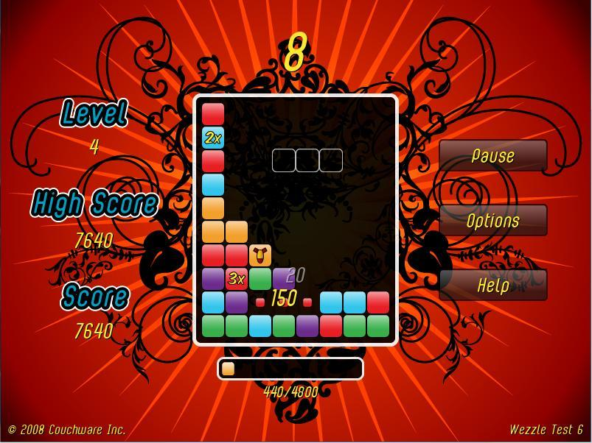
Timer
Progress Indicator
Game board
Piece Consumption
Piece Score
Line Score
Piece
Figure 2. Wezzle Game Interface

The Wezzle game interface contains the following elements: a timer, a game board, a selector, a progress indicator, a button bar and a score indicator (not pictured).
The timer indicates how much time the player has left to place her piece. Once the timer reaches zero, the piece is placed, and the timer is reset.
The game board holds the tiles that the player interacts with using the selector.
The piece is used to interact with the tiles on the game board. The piece changes colour from yellow to red at frequency inversely related to the amount of time remaining. The piece may rotated or moved using the game controls.
The progress indicator indicates the player’s current score. Once the progress indicator is full, the level is completed and the indicator resets to empty.

Art Style
Wezzle has art-nouveau-inspired pixel graphics, heavily influenced by a sensibility based in hand-drawn illustration as well as contemporary urban art.

Music Style
Wezzle has custom music with three separate flavors. Players have the option of choosing the musical flavour that suits their taste as well as combining all thre flavours. The style of music is hip-hop instrumental.

Multiplayer
There are currently plans to create a multiplayer version of Wezzle, however these are not in development as of this time.

Online Features
Wezzle players with an Internet-enabled handset will be able to upload and compare their scores with other players via the Couchware website. Players will also have the option to download alternate background art and tile-sets.

Game Images

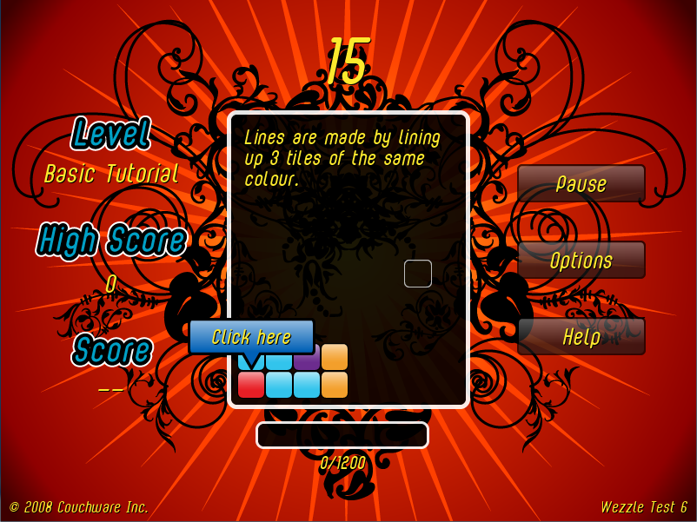
Figure 3. The introduction Tutorial.

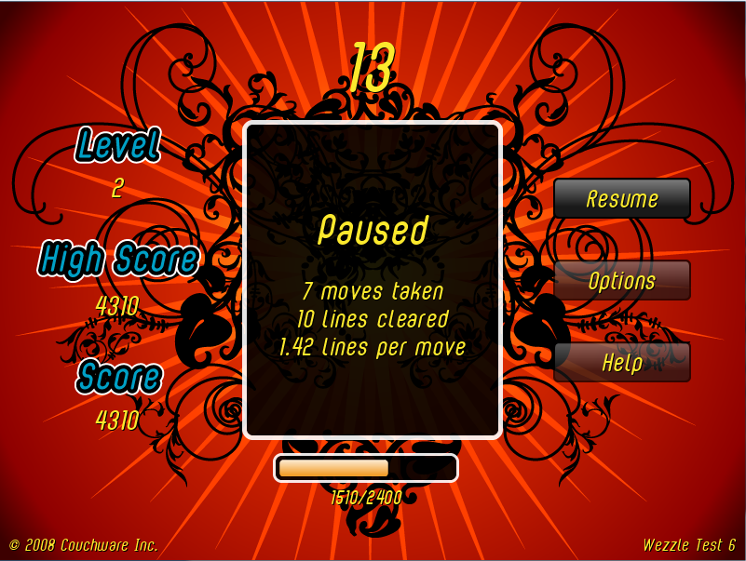
Figure 4. Wezzle Pause Screen.
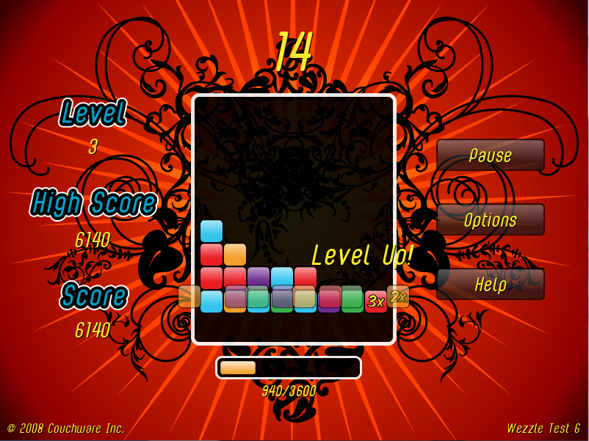
Figure 5. Level up
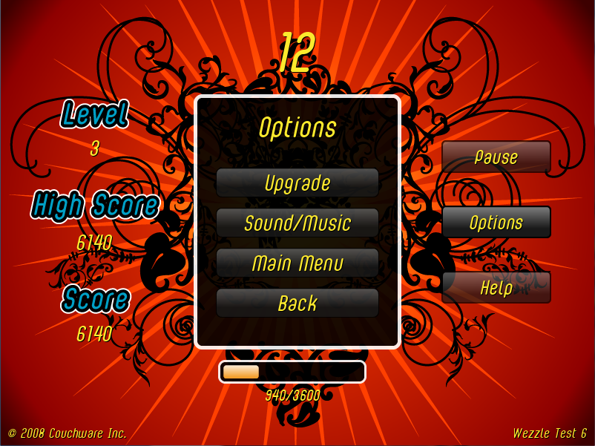
Figure 6. In-game Menu

Team Members
Kevin Grad, B.Sc.
Programmer/ Designer
Kevin is responsible for the game logic.
Cameron McKay, B.Sc., M.Sc.
Programmer / Designer
Cameron is responsible for the user interface and graphics engine.
Renee Lung, B.A.(Hons)
Art Direction
Renee is responsible for all in-game and promotional artwork.
Sam Lee, B.Sc.
Music Direction
Sam is responsible for all in-game and promotional music.

